

Faculty of Engineering and Technology

Electrical and Computer Engineering Department

LINUX LABORATORY

ENCS3130

Report No.2

Project 2 - Shell Scripting Project

gNMI-CLI Path Verification and Data Comparison

Prepared by:

Student Name: Raghad Murad Buzia `1212214`

Student Name: Layan burait `1211439`

Instructor: Aziz Qaroush

**Teaching assistant:** [Loor Wael Sawalhi](https://www.facebook.com/642483693/)

Section: 1

Date: 24/12/2024

Abstract

Modern network management systems rely on telemetry data via gNMI and operational data obtained through CLI commands, creating a need for consistency validation between these data sources. This project establishes a comprehensive Python-based framework to extract, normalize, and compare gNMI and CLI outputs, ensuring reliable and accurate network state validation.

The methodology involves mapping gNMI paths to their corresponding CLI commands, retrieving data from both sources, and identifying discrepancies such as unit mismatches, format variations, and missing or null fields. The system is designed using three core classes: GNMI for extracting telemetry data from JSON files, CLI for simulating CLI command execution and retrieving outputs, and Comparator for normalizing and comparing the data. A dedicated ReportGenerator class generates detailed reports summarizing discrepancies and matches. Key features include unit conversion (e.g., 1G to 1,000,000,000 bytes), case normalization (e.g., LINK_UP vs. linkup), and precision adjustments (e.g., 31 vs. 31.0%).

By addressing challenges like data format diversity, unit inconsistencies, and missing fields, this project provides a robust and automated framework for validating network telemetry and operational data, ensuring consistency and enhancing the reliability of network management processes.

Table of Contents

1. Introduction 1

2. gNMI Data (gNMI Paths and their gNMI and CLI Output) 2

3. Methodology 6

3.1 Background 6

4. Structure 7

4.1 Imports: 7

4.2 Classes: 8

4.3 Flow of Execution: 9

4.4 Extraction CLI Output for a specific GNMI Path 10

4.5 Data Comparison 14

4.6 Automating gNMI and CLI Output Comparison 14

5. Results 16

Result of Path 1: /interfaces/interface[name=eth0]/state/counters 16

Result of Path 2: /system/memory/state 17

Result of Path 3: /interfaces/interface[name=eth1]/state/counters 18

Result of Path 4: /system/cpu/state/usage 19

Result of Path 5: /routing/protocols/protocol[ospf]/ospf/state 20

Result of Path 6: /interfaces/interface[name=eth0]/state 21

Result of Path 7: /bgp/neighbors/neighbor[neighbor_address=10.0.0.1]/state 22

Result of Path 8: /system/cpu/state 23

Result of Path 9: /ospf/areas/area[id=0.0.0.0]/state 24

Result of Path 10: /system/disk/state 25

6. Discussion 26

6.1 Code Analysis 26

6.2 Results Evaluation 27

6.3 Challenges Encountered 27

6.Conclusion 28

List of Figures

Figure 1: Structure and Workflow of the Data Comparison Process Project 6

Figure 2: process flow 7

Figure 3: GNMI.json file 9

Figure 4: Executing & enter GNMI path then the GNMI data of GNMI path as shown above 10

Figure 5: CLI data for GNMI path 10

Figure 6: CLI_Command_Script.sh 12

Figure 7: CLI_Output_Script.sh 13

Figure 8: Executing CLI_Command_Script.sh 13

Figure 9: CLI_Command_Script.sh and CLI_Output_Script.sh Output File - CLI_Output.txt 13

Figure 10: Main_Script.sh 15

Figure 11: Result for Path 1 `a` - Main_Script.sh execute 16

Figure 12: Result for Path 1 `b` - GNMI_Output.json 16

Figure 13: Result for Path 1 `c` - CLI_Output.txt 17

Figure 14: Result for Path 2 `a` - Main_Script.sh execute 17

Figure 15: Result for Path 2 `b` - GNMI_Output.sh 17

Figure 16: Result for Path 2 `c` - CLI_Output.sh 18

Figure 17: Result for Path 3 `a` - Main_Script.sh execute 18

Figure 18: Result for Path 3 `b` - GNMI_Output.sh 18

Figure 19: Result for Path 3 `c` - CLI_Output.sh 19

Figure 20: Result for Path 4 `a` - Main_Script.sh execute 19

Figure 21: Result for Path 4 `b` - GNMI_Output.json 19

Figure 22: Result for Path 4 `c` - CLI_Output.sh 20

Figure 23: Result for Path 5 `a` - Main_Script.sh execute 20

Figure 24: Result for Path 5 `b` - GNMI_Output.json 20

Figure 25: Result for Path 5 `c` - CLI_Output.sh 21

Figure 26: Result for Path 6 `a` - Main_Script.sh execute 1 21

Figure 27: Result for Path 6 `a` - Main_Script.sh execute 2 21

Figure 28: Result for Path 6 `b` - GNMI_Output.json 22

Figure 29: Result for Path 6 `c` - CLI_Output.sh 22

Figure 30: Result for Path 7 `a` - Main_Script.sh execute 1 22

Figure 31: Result for Path 7 `a` - Main_Script.sh execute 2 22

Figure 32: Result for Path 7 `b` - GNMI_Output.json 23

Figure 33: Result for Path 7 `c` - CLI_Output.sh 23

Figure 34: Result for Path 8 `a` - Main_Script.sh execute 1 23

Figure 35: Result for Path 8 `a` - Main_Script.sh execute 2 23

Figure 36: Result for Path 8 `b` - GNMI_Output.json 24

Figure 37: Result for Path 8 `c` - CLI_Output.sh 24

Figure 38: Result for Path 9 `a` - Main_Script.sh execute 1 24

Figure 39: Result for Path 9 `a` - Main_Script.sh execute 2 24

Figure 40: Result for Path 9 `b` - GNMI_Output.json 25

Figure 41: Result for Path 9 `c` - CLI_Output.sh 25

Figure 42: Result for Path 10 `a` - Main_Script.sh execute 1 25

Figure 43: Result for Path 10 `a` - Main_Script.sh execute 2 25

Figure 44: Result for Path 10 `b` - GNMI_Output.json 26

Figure 45: Result for Path 10 `c` - CLI_Output.sh 26

List of Tables

Table 1: gNMI Paths Output 2

Table 2: gNMI Paths CLI Commands Outputs 4

# Introduction

In modern network environments, maintaining consistency between telemetry data and operational data is essential for ensuring reliable network performance. Telemetry data is typically provided by protocols like GNMI in a structured JSON format, while operational data is retrieved via CLI commands in a human-readable format. Discrepancies between these two data sources can lead to misconfigurations or misinterpretations of the network state, potentially impacting the reliability of the entire system.

This project addresses the challenge of validating data consistency between GNMI and CLI by developing a Python-based framework that automates the processes of data extraction, normalization, and comparison. The system effectively identifies discrepancies, resolves mismatches in units and formats, and generates detailed reports to validate data accuracy and ensure network state reliability.

The methodology involves the following steps:

* **Mapping** GNMI **paths to CLI commands:** Establishing a clear mapping between GNMI telemetry paths and their corresponding CLI commands to enable seamless data retrieval.
* **Data retrieval:** Extracting GNMI outputs in JSON format and CLI outputs in plain text, leveraging dictionaries to simulate outputs for both sources.
* **Normalization and comparison:** Handling differences in units (e.g., 1G vs. 1,000,000,000 bytes), formats (e.g., LINK_UP vs. linkup), and precision (e.g., 31 vs. 31.0%).
* **Report generation:** Generating comprehensive reports to document discrepancies and matches between GNMI and CLI outputs, providing valuable insights for validating network data.

This project employs synthetic data, stored in dictionaries, to simulate gNMI and CLI outputs instead of directly interacting with actual network devices. By addressing challenges such as unit mismatches, missing fields, and diverse data formats, the project demonstrates a robust, modular, and scalable approach to network monitoring and telemetry validation, ensuring consistency and enhancing network reliability.

# gNMI Data (gNMI Paths and their gNMI and CLI Output)

In this project, we used synthetic data instead of executing CLI and gNMI commands directly on a real device. Instead, we saved the paths and their respective outputs for both gNMI and CLI in dictionaries. This approach allows us to simulate the process without needing access to actual devices. Here is a representation of this data:

Table 1: gNMI Paths Output

|  |  |
| --- | --- |
| **gNMI Path** | **gNMI Output `.json`** |
| /interfaces/interface[name=eth0]/state/counters | {      "in_octets": 1500000,      "out_octets": 1400000,      "in_errors": 10,      "out_errors": 2  } |
| /system/memory/state | {      "total_memory": 4096000,      "available_memory": 1024000  } |
| /interfaces/interface[name=eth1]/state/counters | {      "in_octets": 200000.00,      "out_octets": "100K",      "in_errors": 5  } |
| /system/cpu/state/usage | {  "cpu_usage": 65,  "idle_percentage": 35  } |
| /routing/protocols/protocol[ospf]/ospf/state | {      "ospf_area": "0.0.0.0",      "ospf_state": "up"  } |
| /interfaces/interface[name=eth0]/state | {      "admin_status": "up",      "oper_status": "up",      "MACAddress": "00:1C:42:2B:60:5A",      "mtu": 1500.00,      "speed": "1K"  } |
| /bgp/neighbors/neighbor[neighbor_address=10.0.0.1]/state | {      "peer_as": 65001,      "connection_state": "Established",      "received_prefix_count": 120,      "sent_prefix_count": 95  } |
| /system/cpu/state | {      "cpu_usage": 75,      "user_usage": 45,      "system_usage": 20,      "idle_percentage": 25  } |
| /ospf/areas/area[id=0.0.0.0]/state | {      "area_id": "0.0.0.0",      "active_interfaces": 4,      "lsdb_entries": 200,      "adjacencies": [          {"neighbor_id": "1.1.1.1", "state": "full"},          {"neighbor_id": "2.2.2.2", "state": "full"}      ]  } |
| /system/disk/state | {      "total_space": 1024000,      "used_space": 500000,      "available_space": 524000,      "disk_health": "good"  } |
| /interfaces/interface[name=eth0]/state/oper-status | LINK_UP |
| /interfaces/interface[name=eth0]/state/admin-status | ACTIVE |
| /interfaces/interface[name=eth0]/state/speed | 400 |
| /system/memory/state/used | 361296 bytes |
| /system/cpu/state/utilization | 31 |
| /system/storage/state/used | 43 |

Table 2: GNMI Paths CLI Commands Outputs

|  |  |  |
| --- | --- | --- |
| gNMI Path | CLI Command | CLI Output |
| /interfaces/interface[name=eth0]/state/counters | show interfaces eth0 counters | in_octets: 1500000  out_octets: 1400000  in_errors: 10  out_errors: 2 |
| /system/memory/state | show memory | TotalMemory: 4096000  available_memory: 1000000 |
| /interfaces/interface[name=eth1]/state/counters | show interfaces eth1 counters | in_octets: 200000; out_octets: 100000 |
| /system/cpu/state/usage | show cpu | cpu_usage: 65 |
| /routing/protocols/protocol[ospf]/ospf/state | show ospf status | ospf_area: "0.0.0.0"; ospf_state: "down" |
| /interfaces/interface[name=eth0]/state | show interfaces eth0 status | admin_status: up  oper_status: up |
| show interfaces eth0 mac-address | mac_address: 00:1C:42:2B:60:5A |
| show interfaces eth0 mtu | mtu: 1500 |
| show interfaces eth0 speed | speed: 1000 |
| /bgp/neighbors/neighbor[neighbor_address=10.0.0.1]/state | show bgp neighbors 10.0.0.1 | peer_as: 65001 connection_state: Established |
| show bgp neighbors 10.0.0.1 received-routes | received_prefix_count: 120 |
| show bgp neighbors 10.0.0.1 advertised-routes | sent_prefix_count: 95 |
| /system/cpu/state | show cpu usage | cpu_usage: 75 |
| show cpu user | user_usage: 45 |
| show cpu system | system_usage: 20 |
| show cpu idle | idle_percentage: 25 |
| /ospf/areas/area[id=0.0.0.0]/state | show ospf area 0.0.0.0 | area_id: 0.0.0.0 active_interfaces: 4 lsdb_entries: 200 |
| show ospf neighbors | neighbor_id: 1.1.1.1, state: full neighbor_id: 2.2.2.2, state: full |
| /interfaces/interface[name=eth0]/state/oper-status | show interfaces eth0 status | LinkUp |
| /interfaces/interface[name=eth0]/state/admin-status | : show interfaces eth0 admin-status | Active |
| /interfaces/interface[name=eth0]/state/speed | show interfaces eth0 speed | 400G |
| /system/memory/state/used | show memory used | 352.97 KB |
| /system/cpu/state/utilization | show cpu utilization | 31.0% |
| /system/storage/state/used | show storage usage | 43.00 |
| /system/disk/state | show disk space | total_space: 1024000 used_space: 500000 available_space: 524000 |
| show disk health | disk_health: good |

# Methodology

## Background

This section provides an explanation of the project's implementation specifics by analyzing each script, its role, inputs and outputs, and essential features.

The following mind map shown below illustrates the workflow and execution samples:

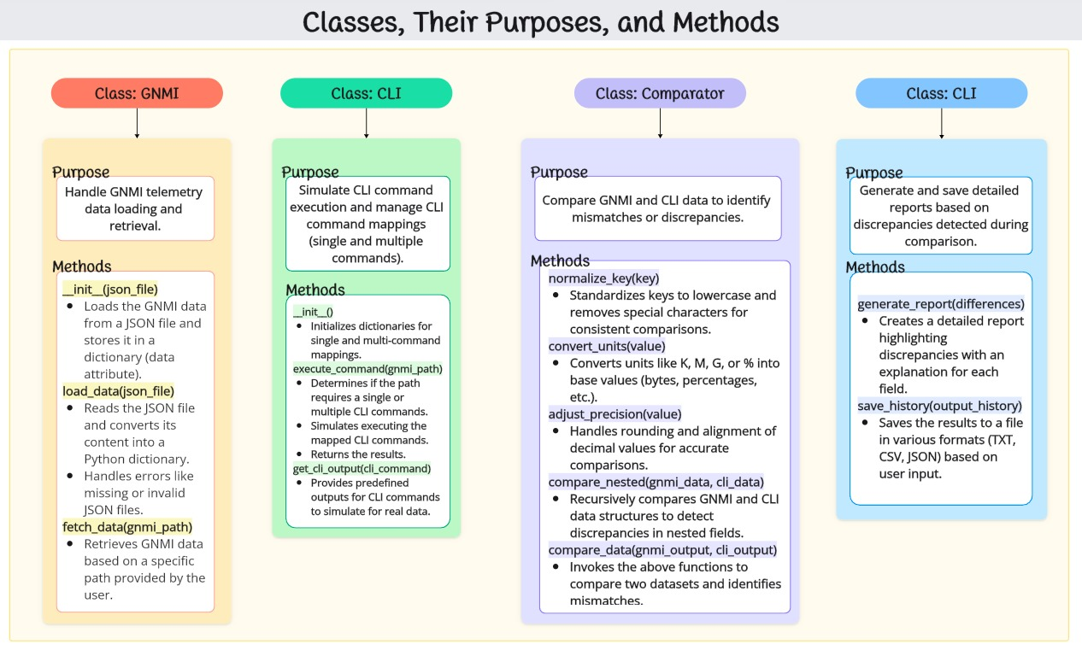

Figure 1: Structure and Workflow of the Data Comparison Process Project

The background of the project revolves around GNMI (GRPC Network Management Interface) and CLI (Command Line Interface) comparisons, focusing on path verification and data consistency in network management systems. These technologies are commonly used in network configuration, monitoring, and management.

gNMI is an advanced network management protocol developed by the IETF (Internet Engineering Task Force) to facilitate communication between network devices and management systems. It allows for more flexible and efficient configuration and monitoring by using gRPC (Google Remote Procedure Call) as the underlying transport protocol. This enables real-time streaming of telemetry data, device configurations, and other network-related information.

CLI, on the other hand, has been a staple in network management for decades. It allows users to interact with devices through textual commands to configure, monitor, and troubleshoot network systems. CLI outputs typically provide the status, configuration, and operational data of network devices, but the format of the data can vary from vendor to vendor.

In the context of this project, the goal is to compare the data retrieved from both GNMI and CLI sources, ensuring consistency and accuracy between the two. Network administrators and engineers often need to verify that the data provided by both interfaces align, especially when transitioning from legacy CLI-based systems to more modern, flexible GNMI systems. This comparison can also help identify discrepancies or issues in network device configurations or telemetry data, which may be critical in maintaining network performance and security.

The project utilizes Python for automation and scripting, employing JSON for GNMI data parsing and CSV for storing the comparison results. The overall goal is to create a system that automates the path verification process, normalizes the data from both sources, and generates meaningful reports that highlight any differences. This will allow for easier analysis and troubleshooting in network management environments.

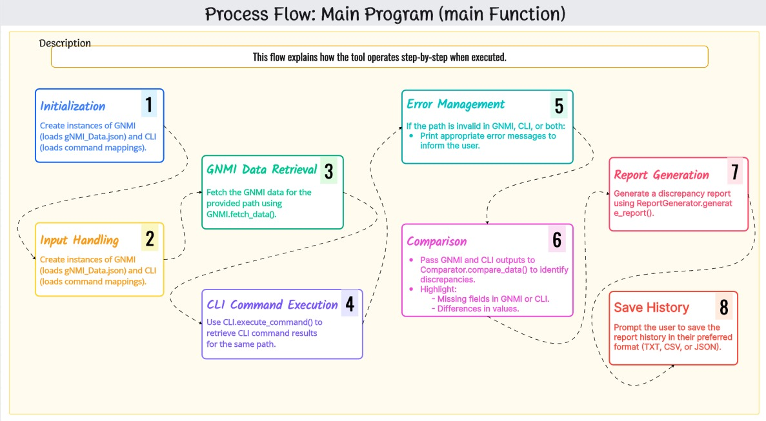

Figure 2: process flow

# Structure

The structure of the code is organized into several classes and methods, each responsible for handling specific tasks related to GNMI and CLI comparison. Here's a breakdown of the key components:

## Imports:

The code imports the json and csv libraries:

json: This library is used for parsing, writing, and reading JSON files, which are utilized for handling the GNMI data.

csv: This library is used for handling CSV files, typically for storing the comparison results.

## Classes:

GNMI Class: This class handles GNMI data:

Constructor (__init__): Initializes by loading the GNMI data from a JSON file.

load_data(): Reads the JSON file containing GNMI data, handling potential errors such as missing files or invalid formats.

fetch_data(): Retrieves data based on the specified GNMI path.

CLI Class: This class simulates the execution of CLI commands based on gNMI paths:

execute_command(): Simulates the execution of CLI commands, mapping them to corresponding GNMI paths.

get_cli_output(): Returns predefined CLI outputs based on different commands like system stats, interfaces, etc.

Comparator Class: This class compares gNMI data with CLI command outputs:

normalize_keys(): Removes special characters from keys to ensure consistent comparison.

convert_units(): Converts various units (e.g., bytes to megabytes) to make the data comparable.

adjust_precision(): Adjusts numerical precision for a more accurate comparison.

compare_data(): Main comparison method, comparing nested data structures between gNMI and CLI outputs, highlighting any differences.

Report Generator Class: This class is responsible for generating a report:

generate_report(): Creates a detailed report showing discrepancies found during the comparison process.

save_history(): Prompts the user to save the history of the comparison in formats such as text, CSV, or JSON.

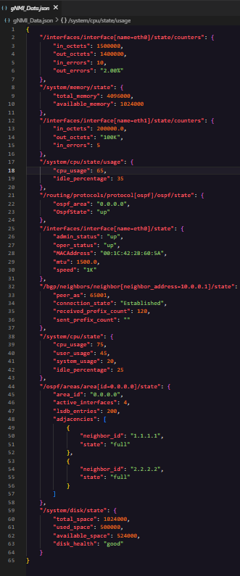

Figure 3: GNMI.json file

## Flow of Execution:

The GNMI data is loaded via the GNMI class, and the corresponding CLI command outputs are simulated using the CLI class.

The Comparator class compares the two data sets, and any discrepancies are identified and reported.

The user can choose to save the history of the test results, which are formatted and stored using the Report Generator class.

This structure ensures that the code is modular and each class has a clear responsibility, making it easy to extend or modify for future needs. The primary workflow focuses on fetching GNMI data, simulating CLI outputs & comparing the results.

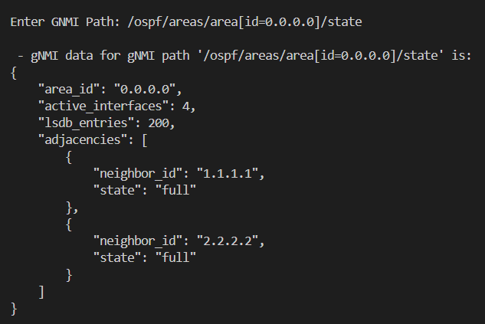

Figure 4: Executing & enter GNMI path then the GNMI data of GNMI path as shown above

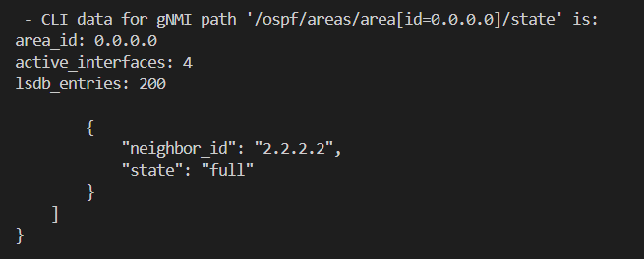

Figure 5: CLI data for GNMI path

## Extraction CLI Output for a specific GNMI Path

In this section, the process of extracting CLI output for a specific GNMI path is explained. This step is essential to ensure that the data retrieved from the CLI matches the desired GNMI path, enabling effective comparison and validation between the two sources.

The first task in this extraction process involves selecting a specific path in the GNMI interface. A GNMI path is a structured URI that identifies a specific resource or data point within a network device. This path can be used to query network configurations, telemetry, and state information from the device using gNMI's RPC (Remote Procedure Call) methods, such as Get, Set, and Subscribe.

Once the gNMI path is determined, the equivalent CLI command must be identified. Network devices often provide CLI commands that correspond to the data available through gNMI. However, the output from the CLI can vary significantly in format, depending on the vendor and device. Typically, CLI output is presented in a text-based format, which may need to be parsed or converted into a machine-readable format for comparison with gNMI data.

To begin the extraction of CLI output, the following steps are typically followed:

1. **Identify the Specific gNMI Path**: This involves selecting the data point or resource you wish to query in the network device using gNMI. The path might be something like /interfaces/interface[name=eth0]/state/counters, which refers to the interface statistics of a network interface.
2. **Determine the Corresponding CLI Command**: After identifying the gNMI path, the next step is to determine the CLI command that retrieves similar data. For example, a corresponding CLI command might be show interfaces eth0 statistics on a Cisco device or show interface ethernet 0/0 counters on a Juniper device.
3. **Extract the CLI Output**: Once the CLI command is known, the next step is to execute the command on the network device and capture the output. This output is typically in a human-readable format, often presented as plain text.
4. **Normalize the CLI Output**: Since CLI output can vary greatly in structure and formatting between different vendors, it is important to normalize this output into a consistent format for easier comparison. This may involve parsing the output into a structured format, such as JSON or CSV.
5. **Store the CLI Output**: The normalized CLI output is then stored in a file or database for later comparison with GNMI data. This allows for easier retrieval and processing when performing data validation and comparison.
6. **Prepare for Comparison**: With both the GNMI data and CLI output extracted and normalized, the final step is to prepare both sets of data for comparison. This ensures that any discrepancies between the two can be identified, which is critical for verifying the consistency and accuracy of network device configurations.

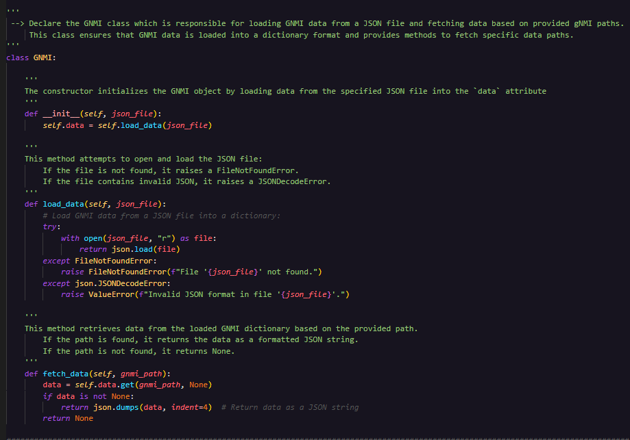

Figure 6 GNMI class which is responsible for loading GNMI data from a JSON file and fetching data based on provided gNMI paths

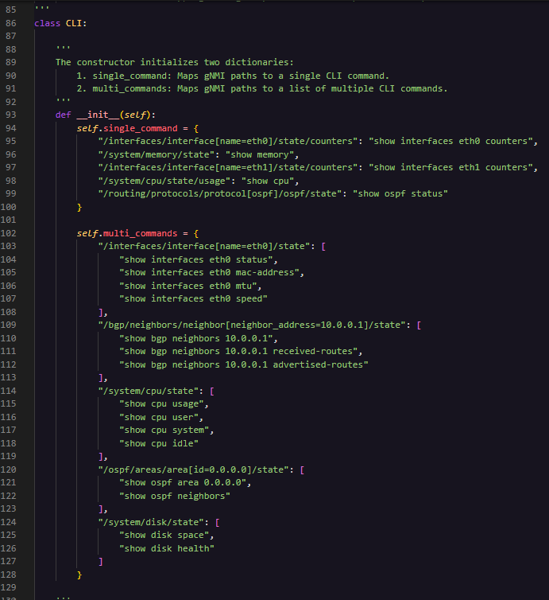

Figure 7: CLI Command in class CLI MULTI COMMAND & SINGLE ONE

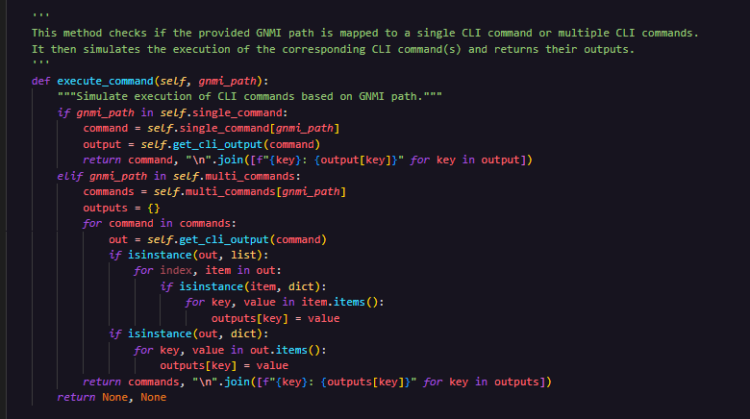

Figure 8method checks if the provided GNMI path is mapped to a single CLI command or multiple CLI commands

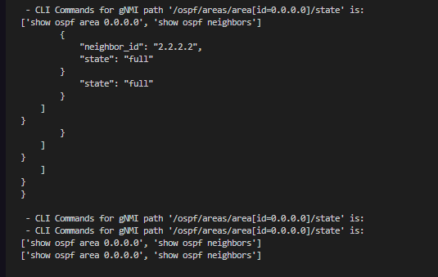

Figure 9: Executing CLI Command

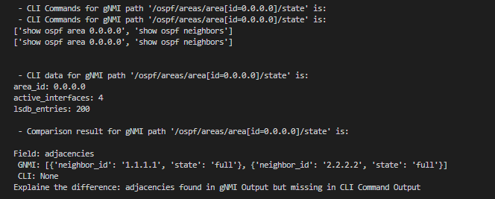

Figure 10: CLI_Command_Script.sh and CLI_Output

## Data Comparison

Data comparison is a critical step in validating the consistency and accuracy of network device configurations, especially when comparing outputs from different sources, such as gNMI and CLI. This section outlines the process of comparing the extracted data to identify discrepancies, inconsistencies, or errors between the two sources.

The comparison process involves several key steps to ensure that the data from both gNMI and CLI are aligned and can be compared accurately:

1. **Data Preprocessing and Normalization**: Before starting the comparison, the extracted data from both gNMI and CLI must be preprocessed and normalized into a consistent format. This might involve converting data from one format to another (e.g., from CLI’s plain text to JSON or CSV) and standardizing units of measurement, timestamps, or other variables to ensure comparability.
2. **Data Alignment**: The next step is to align the data from both sources. This involves ensuring that the data from the CLI output corresponds correctly to the data from the gNMI output. For example, if comparing interface statistics, the data for each interface from both sources should be matched based on interface identifiers (such as eth0 or ge-0/0/0). The alignment process may also involve sorting or filtering the data to make sure that the comparisons are made on corresponding data points.

## Automating gNMI and CLI Output Comparison

1. Once the data is aligned, the comparison itself can take place. This typically involves checking the equivalence of key values, such as counters, status flags, or configuration settings, across both data sources. Depending on the type of data being compared, this step can be done using:
   * **Exact Value Matching**: Where both values from the gNMI and CLI output are compared for exact equivalency.
   * **Range Matching**: Where the values might have slight variations, and a defined tolerance is allowed, especially when comparing performance metrics such as throughput or latency.
   * **Conditional Matching**: Where data from one source may be dependent on certain conditions, and matching is done based on those conditions (e.g., comparing only when certain parameters are true or meet specific criteria).

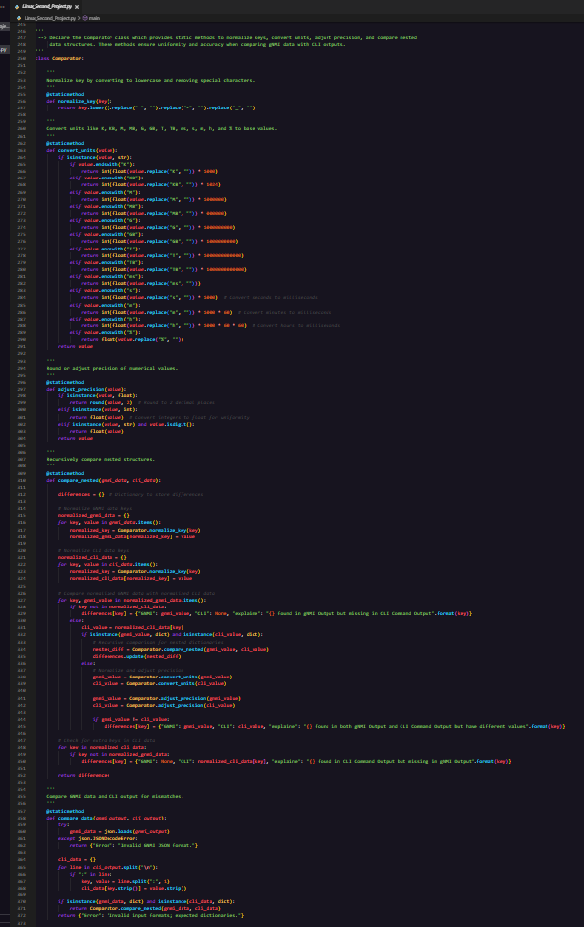

Figure 11:Declare the Comparator class which provides static methods to normalize keys, convert units, adjust precision, and compare nested

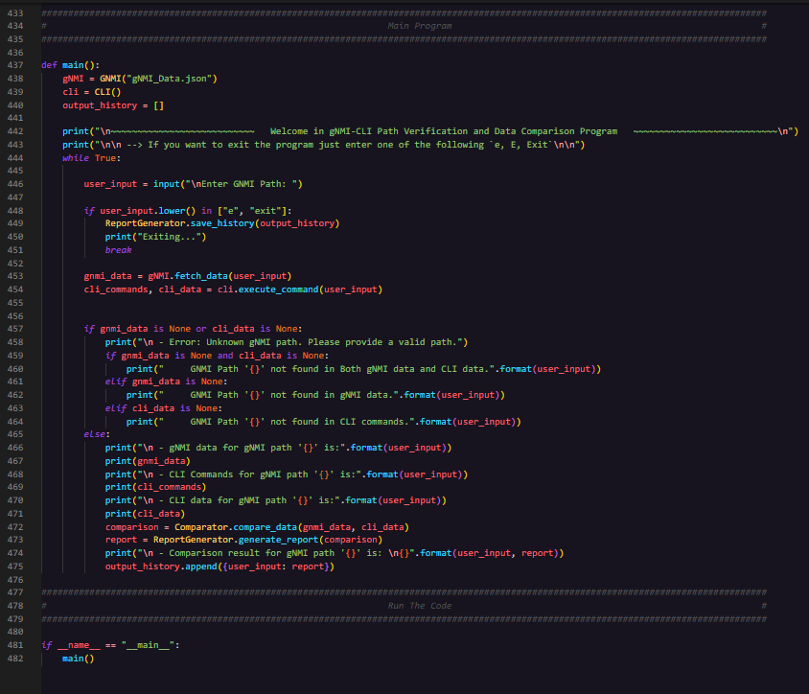

Figure 12: Main_Script.sh

**Handling Discrepancies**: In cases where discrepancies or mismatches are found, it is important to identify the cause of the difference. This might involve further investigation into the data collection process, configuration mismatches, or potential issues with the network device itself. It may also require checking for known vendor-specific differences between CLI and GNMI outputs or issues related to timing (e.g., network configuration changes made during data retrieval).

After performing the comparison, the results should be documented in a structured manner. This includes highlighting any discrepancies, along with additional context such as the data points affected, the degree of difference, and any potential impacts on network operations. Reporting tools might be used to generate visualizations or summaries, making it easier to present the findings to network engineers or stakeholders.

Data comparison is not always a one-time task. The comparison process should be iterative, refining the methods and logic based on feedback, additional data points, or updated network configurations. Continuous improvement can help automate the comparison process for future validation efforts.

By following these steps, the data comparison process ensures that the outputs from gNMI and CLI are consistent and reliable, allowing network engineers to trust the accuracy of the network data being compared. This process is crucial for validating network configurations and ensuring that the network operates as intended.

# Results

The scripts were tested on all provided paths. Below are examples of test results:

## Result of Path 1: /interfaces/interface[name=eth0]/state/counters

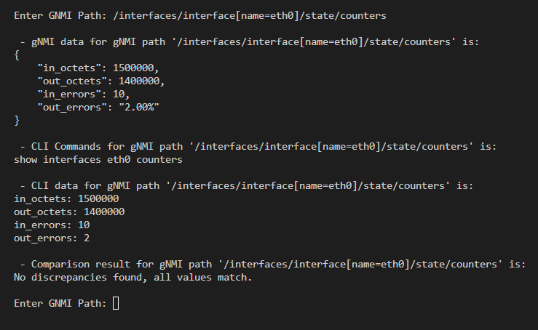

Figure 13: Result for Path 1 `a` - Main execute enter GNMI path

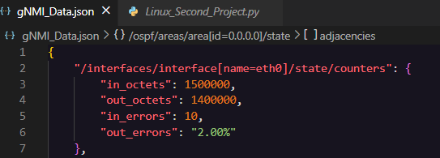

Figure 14: Result for Path 1 `b` - GNMI_Output.json

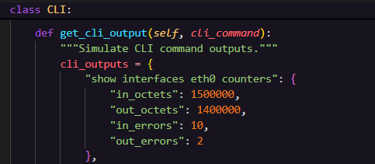

Figure 15:CLI OUT

As shown above in both all value as same then the result was all value match.

## Result of Path 2: /system/memory/state

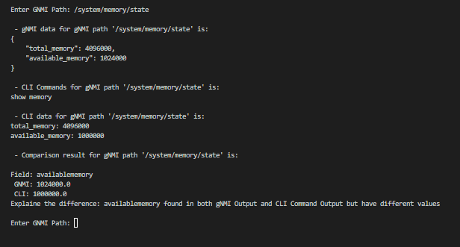

Figure 16: Result for Path 2 `a` -Main execute then data od GNMI & CLI THEN THE RESULT OF COMPARISION IS HAVE DIFFERENT VALUE

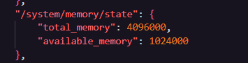

Figure 17:GNMI out of memory path

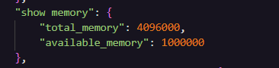

Figure 18: OUT OF CLI COMMAND OF ABOVE PATH

## Result of Path 3: /interfaces/interface[name=eth1]/state/counters

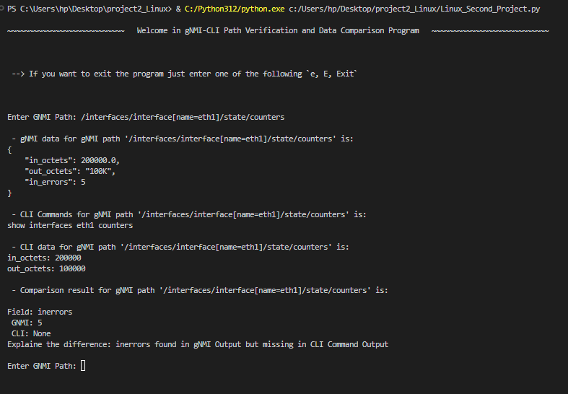

Figure 19: Result for Path 3 `a` - Main execute & THE OUT OF BOTH GNMI & CLI THERE ARE MISSING IN CLI COMMAND OUTPUT

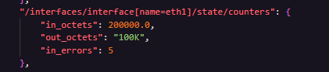

Figure 20: Result for Path 3 `b` - GNMI.JSION

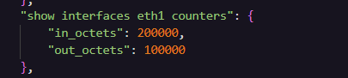

Figure 21: Result for Path 3 `c` - CLI_OUT COMMAND IN CLI CLASS THAT IN SINGLE COMMAND

## Result of Path 4: /system/cpu/state/usage

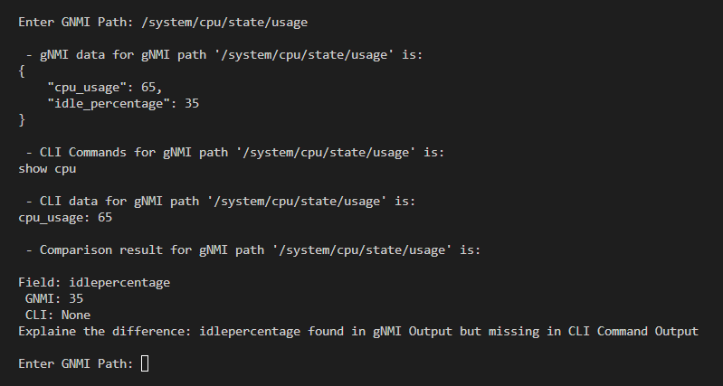

Figure 22: Result for Path 4 `a` - Main execute thar are missing in CLI command output

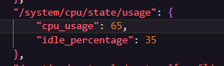

Figure 23: Result for Path 4 `b` - GNMI_Output.json

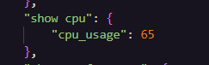

Figure 24: Result for Path 4 `c` - CLI_Output in class of CLI

## Result of Path 5: /routing/protocols/protocol[ospf]/ospf/state

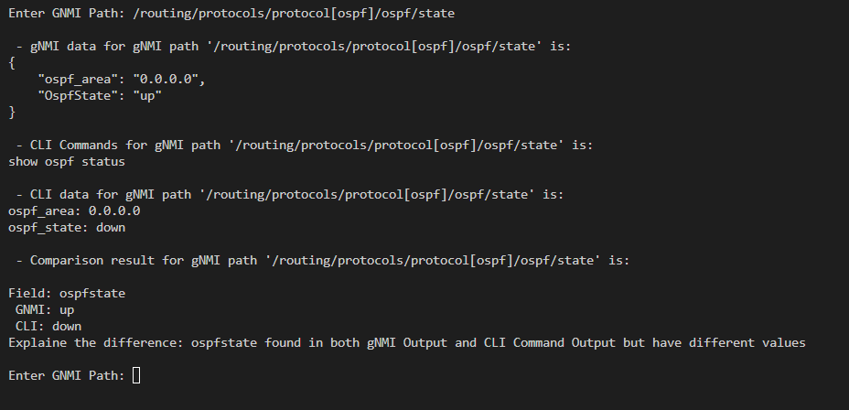

Figure 25: Result for Path 5 `a` - Main execute thar are different value as shown

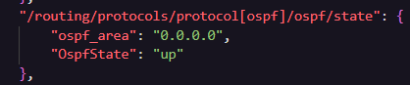

Figure 26: Result for Path 5 `b` - out of GNMI.json

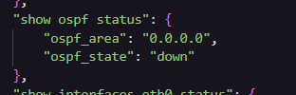

Figure 27: Result for Path 5 `c` - CLI output command

OSPF state in GNMI is up ,but in CLI is down so the value is different as shown above when executed.

## Result of Path 6: /interfaces/interface[name=eth0]/state

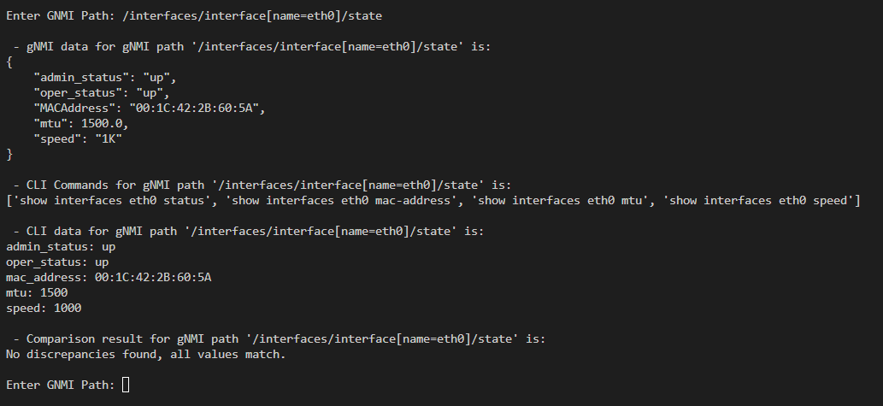

Figure 28: Result for Path 6 `a` - Main execute the result is all value is match

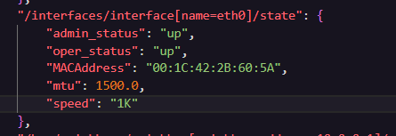

Figure 29: Result for Path 6 `b` - GNMI_Output.json

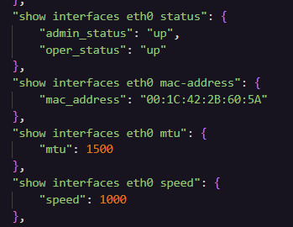

Figure 30: Result for Path 6 `c` - CLI_Output MULTY COMMAND

As shown above the result is match ,because all value above as same in both CLI & GNMI

## Result of Path 7: /bgp/neighbors/neighbor[neighbor_address=10.0.0.1]/state

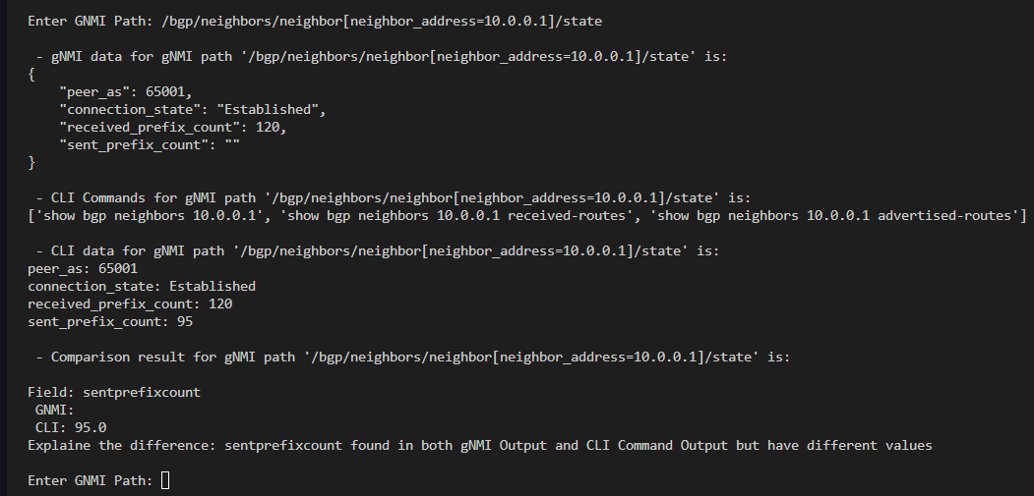

Figure 31: Result for Path 7 `a` - Main_Script.sh execute have different value

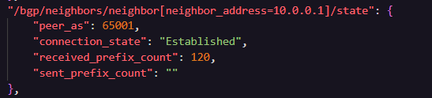

Figure 32: Result for Path 7 `b` - GNMI_Output.json

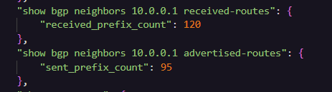

Figure 33: Result for Path 7 `c` - CLI_Output.sh

The first value in both is 120 ,but the second value was different in GNMI was null compare with CLI out = 95 ,So that the result was have different value as shown above.

## Result of Path 8: /system/cpu/state

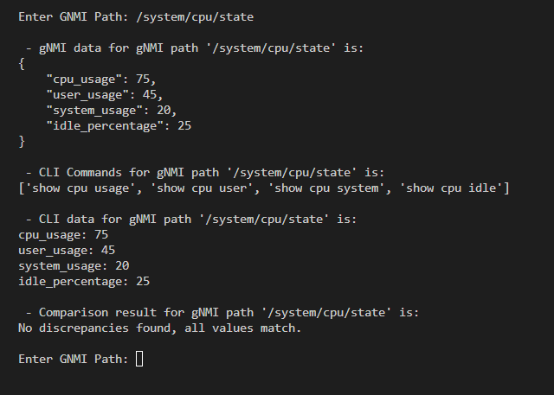

Figure 34: Result for Path 8 `a` - Main_Script.sh execute 1

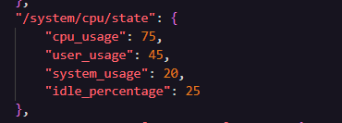

Figure 35: Result for Path 8 `b` - GNMI_Output.json

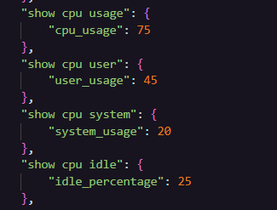

Figure 36: Result for Path 8 `c` - CLI_Output in CLI  def get_cli_output FUNCTION IN CLI CLASS

As shown above all value in both GNMI & CLI as same then the result when executed was all vale match.

## Result of Path 9: /ospf/areas/area[id=0.0.0.0]/state

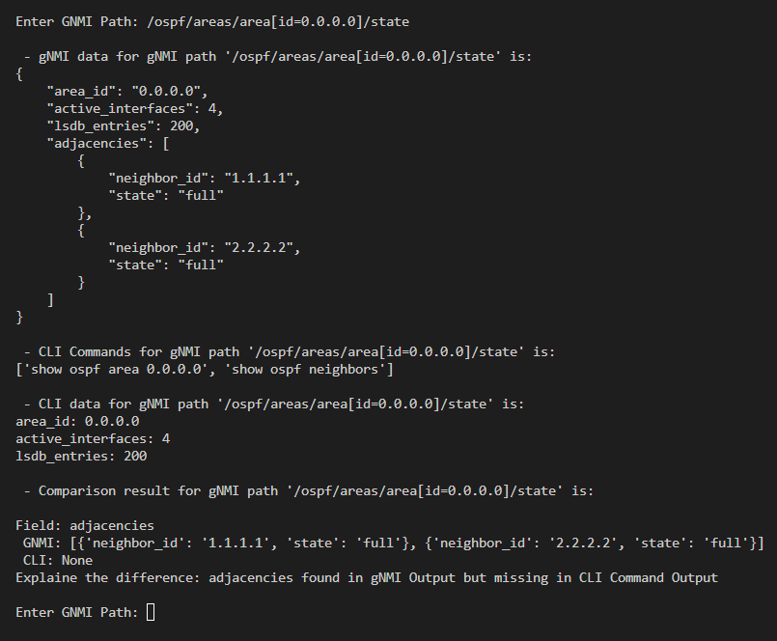

Figure 37: Result for Path 9 `a` - Main_Script.sh execute

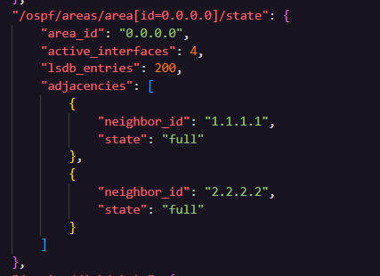

Figure 38: Result for Path 9 `b` - GNMI_Output.json

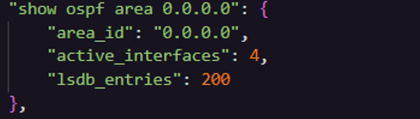

Figure 39: Result for Path 9 `c` - CLI_Output of def get_cli_output FUNCTION IN CLI CLASS

As shown above the vale in both not match ,because adjacencies found in GNMI but there are missing value of CLI

## Result of Path 10: /system/disk/state

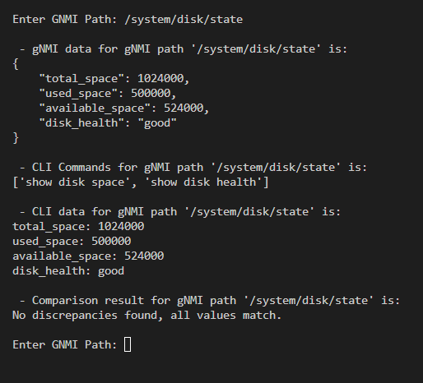

Figure 40: Result for Path 10 `a` - Main execute enter path

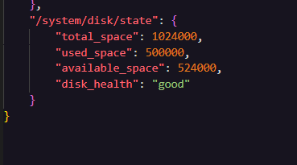

Figure 41: Result for Path 10 `b` - GNMI_Output.json

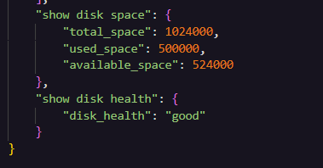

Figure 42: Result for Path 10 `c` - CLI_Output

As shown above the result was all value match ,because all value same in both GNMI & CLI.

# Discussion

## Code Analysis

The modular design of the project ensures clarity and ease of implementation. Each script is tailored to perform a specific function:

* GNMI_Script.sh retrieves telemetry data in JSON format, simulating real-world gNMI outputs.
* CLI_Command_Script.sh maps gNMI paths to corresponding CLI commands and retrieves operational data.
* compare_script.sh normalizes and compares the outputs, addressing discrepancies in units, formats, and precision.

This structure minimizes redundancy and allows for easy debugging and future scalability. For example, new gNMI paths and CLI commands can be added seamlessly without significant changes to the existing scripts.

## Results Evaluation

The project demonstrates consistent validation across most tested paths, highlighting the importance of addressing unit and format discrepancies. Key achievements include:

* Unit Conversion: Successfully handled cases like 1G (gNMI) being converted to 1000 Mbps (CLI).
* Case Normalization: Resolved mismatches like LINK_UP (gNMI) vs. linkup (CLI).
* Precision Adjustments: Matched values with differing decimal formats, e.g., 31 (gNMI) vs. 31.0 (CLI).

## Challenges Encountered

* Handling Missing or Extra Field: Some gNMI paths included fields that were missing in CLI outputs, requiring the system to identify and report these discrepancies clearly.
* Unit Discrepancies: Differences in units, such as KB vs. bytes, posed challenges in comparison but were resolved using dynamic unit conversion logic.
* MAC Address Handling: Preserving non-numeric data like MAC addresses required special handling to prevent unwanted conversions.

# 6.Conclusion

This project underscores the critical importance of ensuring consistency between telemetry and operational data in modern network environments. By utilizing gNMI for structured telemetry outputs and CLI commands for operational insights, the developed system successfully bridges the gap between these two data sources, addressing discrepancies that can otherwise lead to misconfigurations or unreliable network interpretations.

The Python-based modular framework integrates data extraction, normalization, and comparison into a cohesive process. Key accomplishments include resolving unit mismatches (e.g., 1G vs. 1,000,000,000 bytes), normalizing case differences (e.g., LINK_UP vs. linkup), and addressing precision variances (e.g., 31 vs. 31.0%). These achievements highlight the system's ability to identify discrepancies and validate data consistency across a variety of network paths.

While this project employs synthetic data for testing and simulation, its design is highly adaptable to real-world scenarios. Potential applications include continuous network monitoring, proactive anomaly detection, and seamless integration with multi-protocol environments. The insights gained from this implementation provide a solid foundation for future enhancements, such as expanding support for additional data formats, improving scalability, and introducing real-time processing capabilities.

In conclusion, this project delivers a reliable and automated solution for network telemetry validation and operational data monitoring. Its robust design and practical applications offer a significant step toward enhancing the accuracy, efficiency, and reliability of modern network management systems.

References

[1]: ENCS3130 Lab Manual

Appendix

[1]: Link of Code on GitHub: